📘 Assignment: Operating System Installation

🔹 Task 1: Download Ubuntu Desktop ISO and Create a Bootable USB
Objective: Download the latest Ubuntu Desktop ISO image and create a bootable USB drive.
Steps:
1. Visit the Ubuntu Desktop Download Page
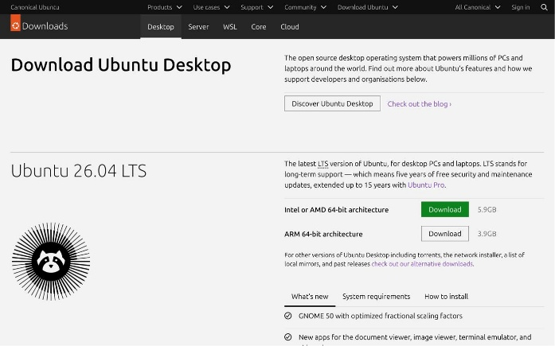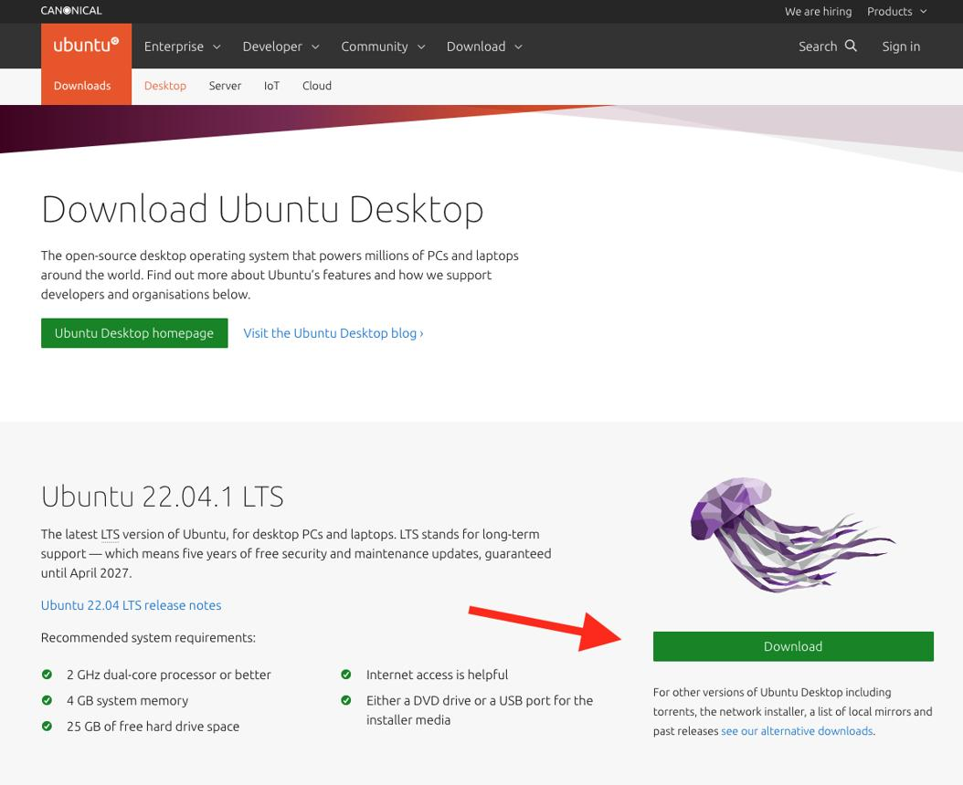
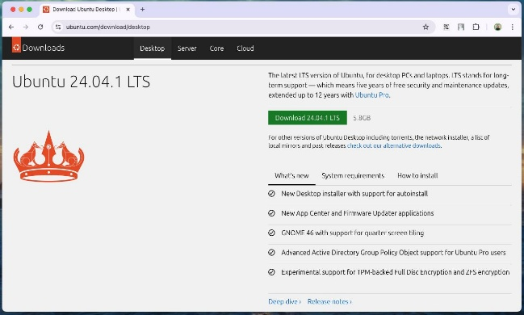
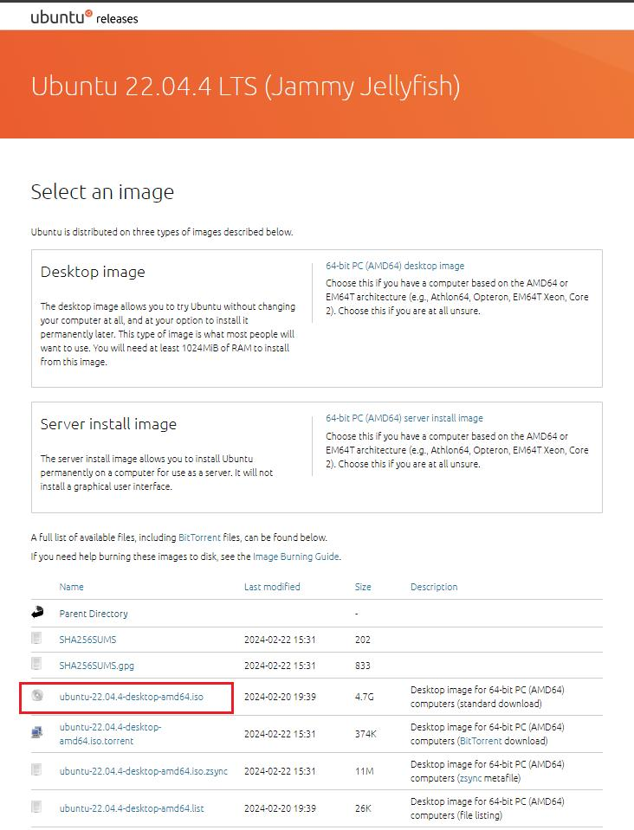
4
Caption:
Step 1: Open the official Ubuntu Desktop Downloads page and select the latest Ubuntu Desktop LTS ISO image.

2. Download the Ubuntu Desktop ISO
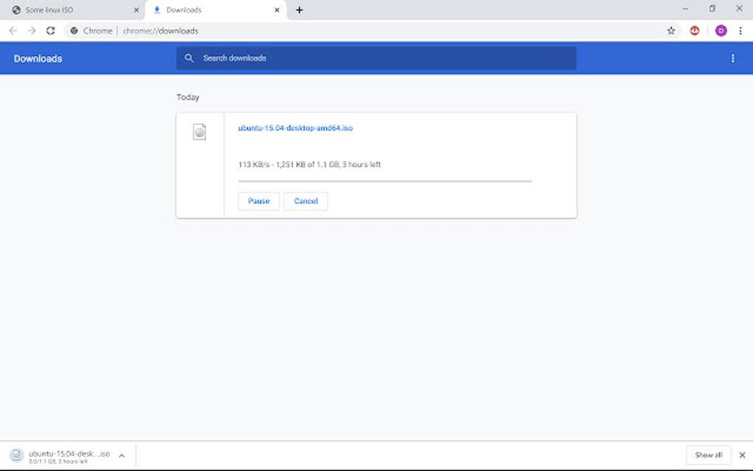
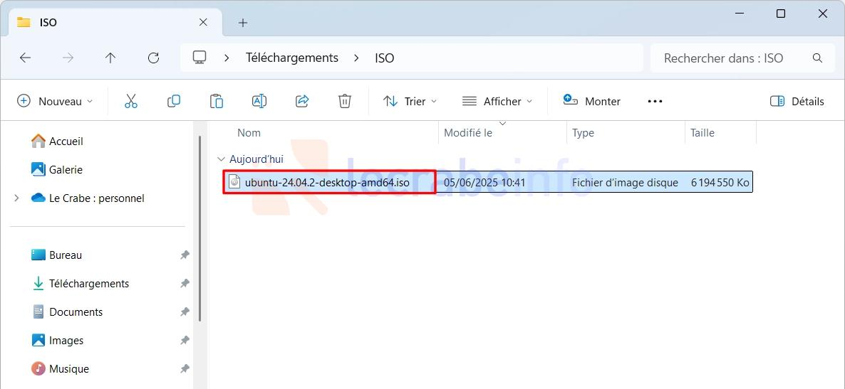
Caption:
Step 2: Download the latest Ubuntu Desktop ISO image and wait until the download completes.

3. Insert an 8 GB (or larger) USB Flash Drive
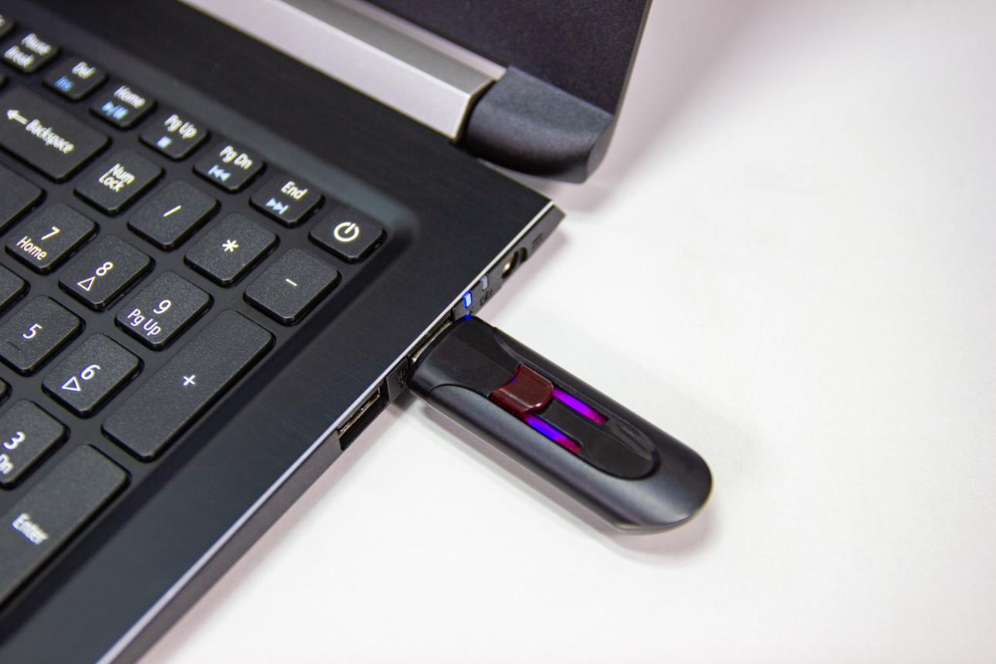
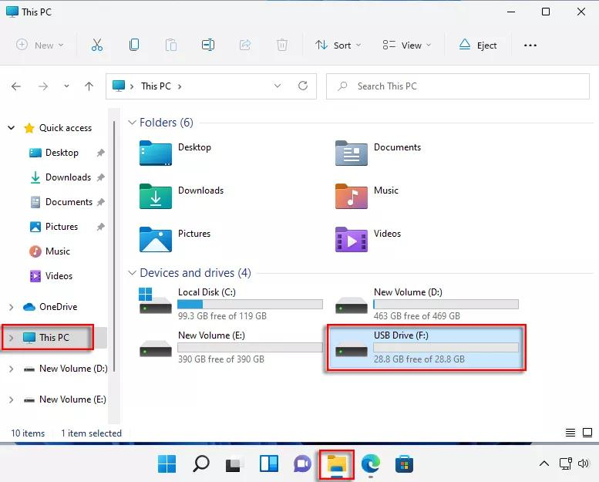
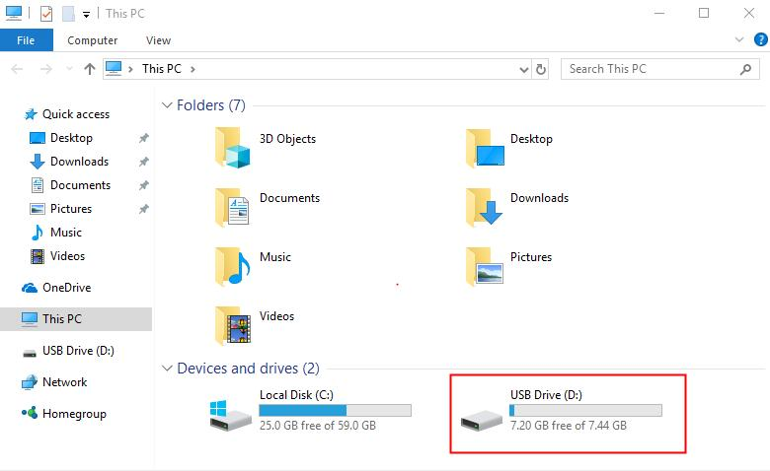
Caption:
Step 3: Insert a USB flash drive (minimum 8 GB) into the computer.

4. Open Rufus
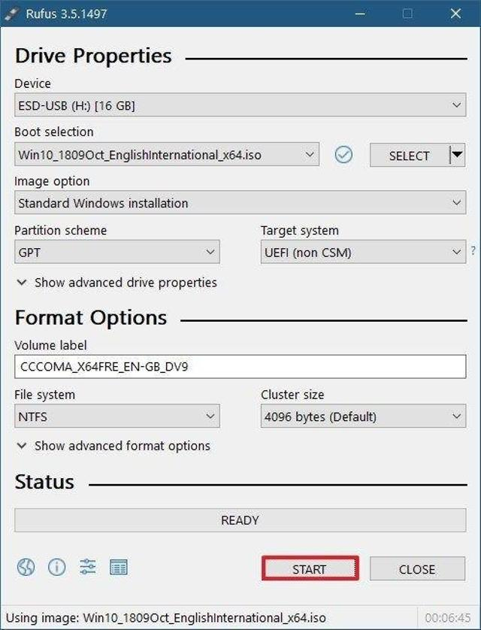

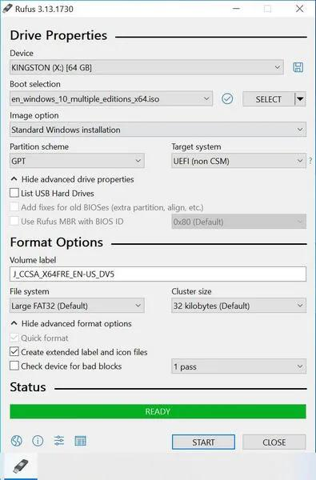
Caption:
Step 4: Launch Rufus on Windows.

5. Select the Ubuntu ISO File
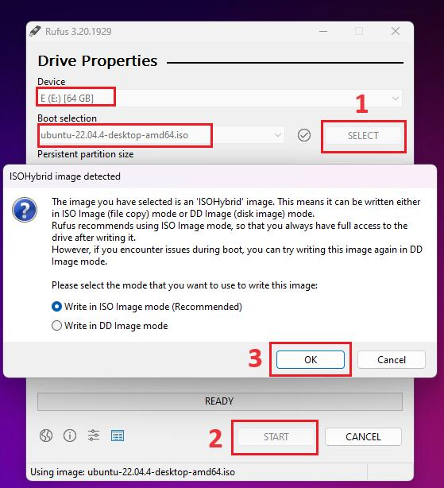
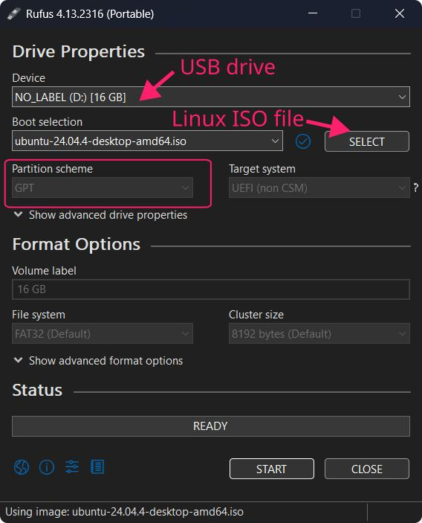
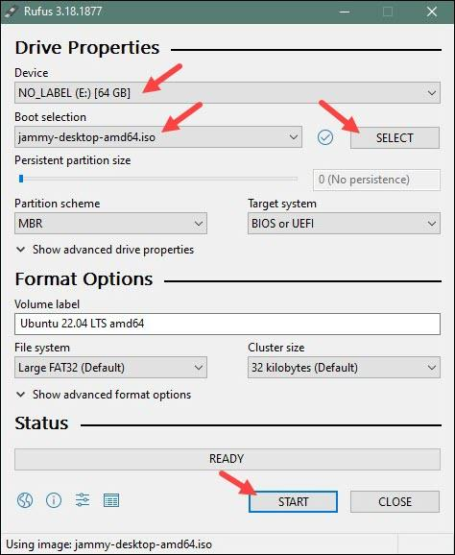
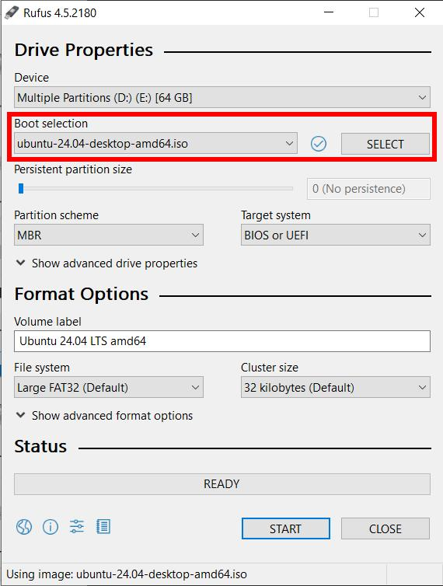
4
Caption:
Step 5: Click SELECT and choose the downloaded Ubuntu ISO file.

6. Select the USB Drive
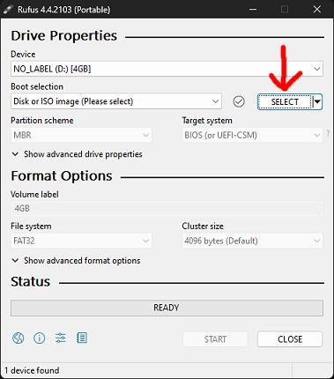
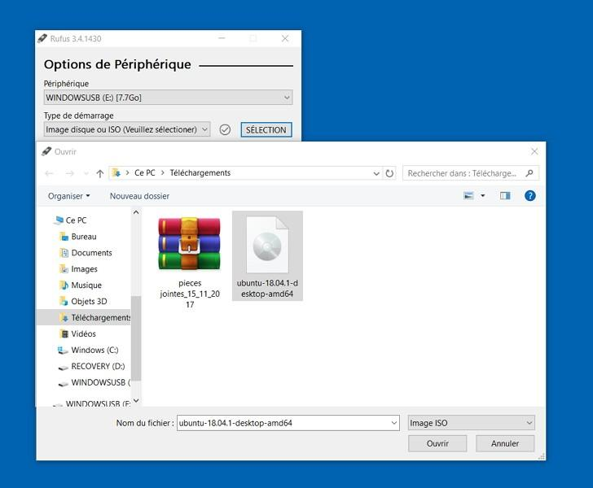
Caption:
Step 6: Select the inserted USB flash drive from the Device list.

7. Click Start
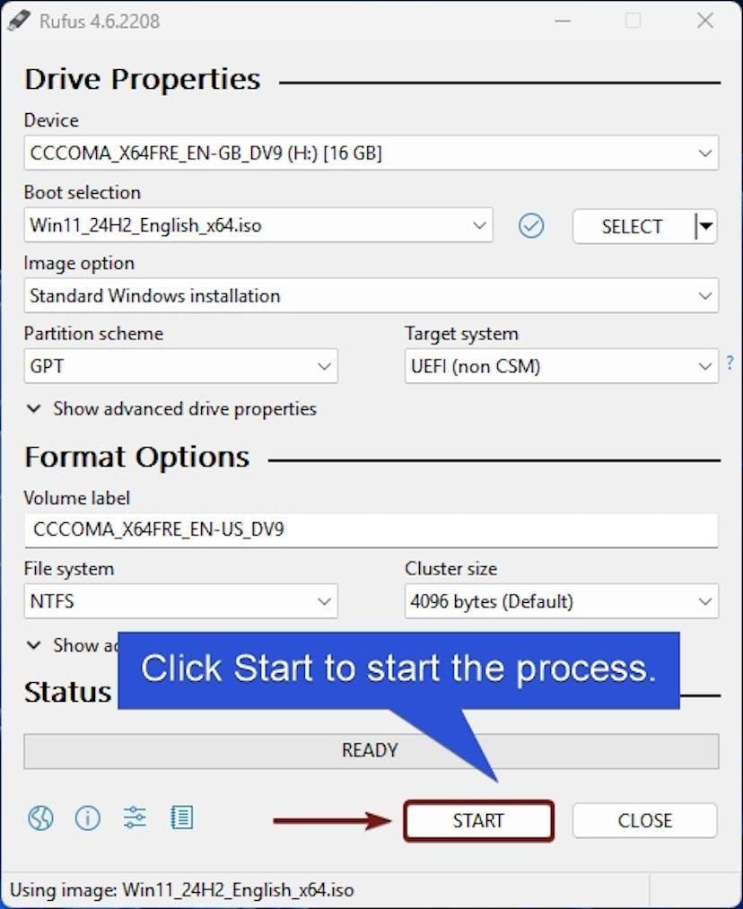
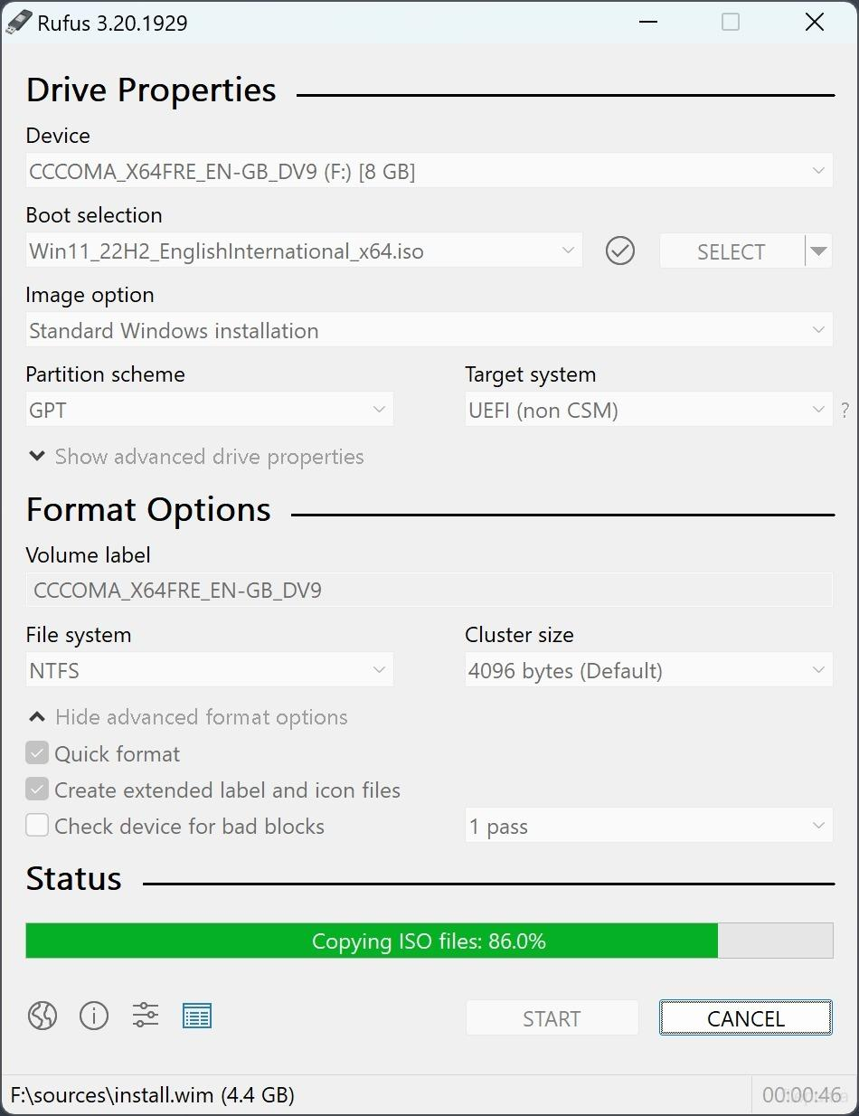
Caption:
Step 7: Click START to begin creating the bootable USB.

8. Bootable USB Successfully Created
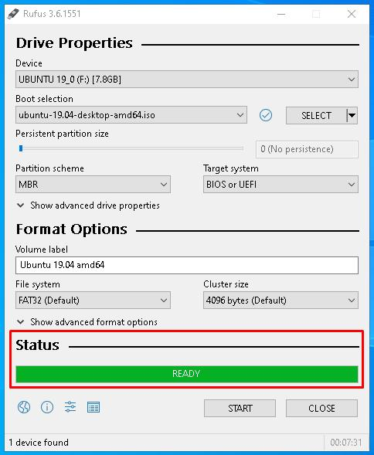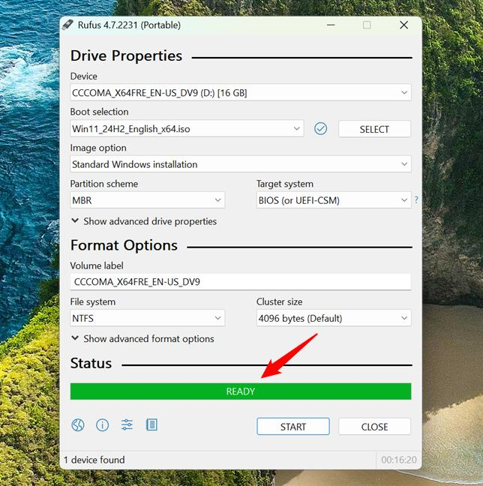

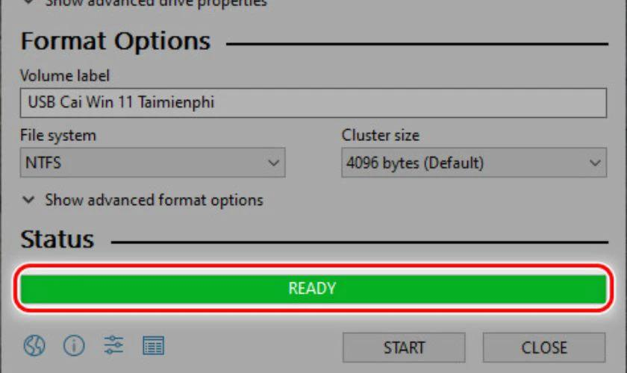
Caption:
Step 8: Wait until the status changes to READY, indicating the bootable USB has been created successfully.

If Using Balena Etcher Instead
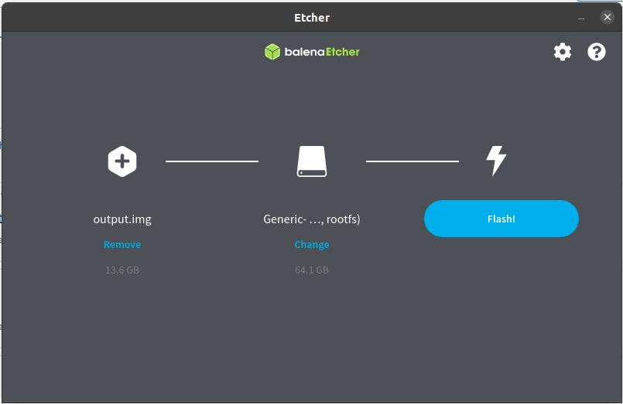
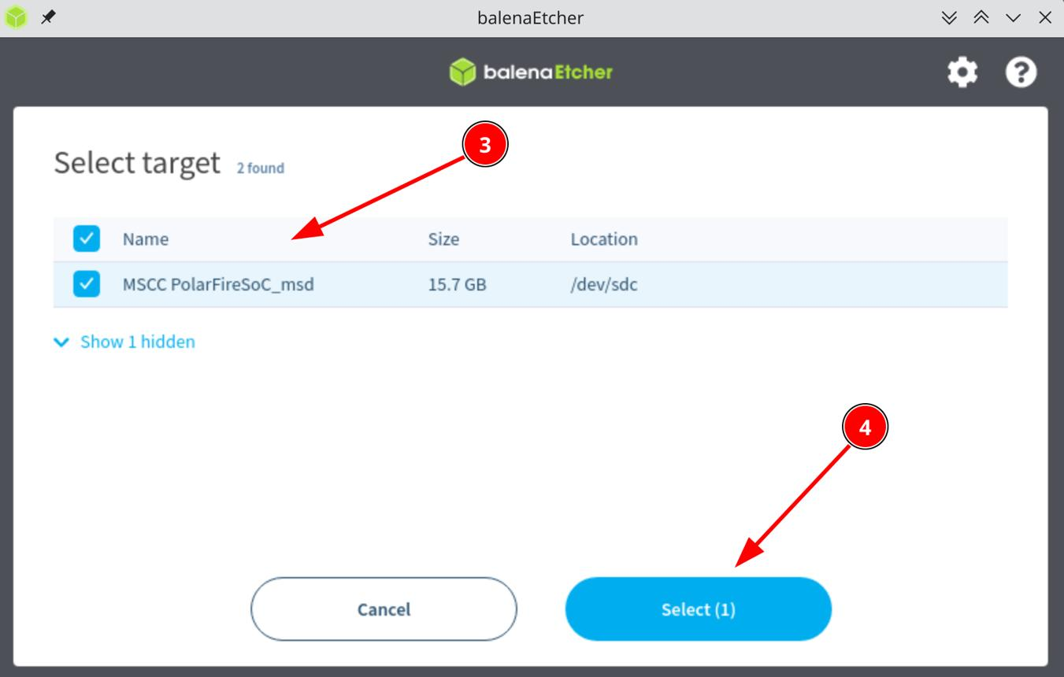
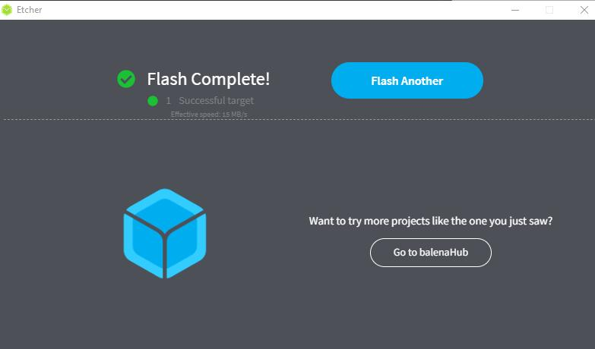
Captions:
- Flash from File – Select the Ubuntu ISO.
- Select Target – Choose the USB drive.
- Flash Complete – Bootable USB created successfully.

🔹 Task 2: Install Ubuntu Desktop on a Virtual Machine
Objective: Install Ubuntu Desktop using VirtualBox or VMware Workstation/Player.
Steps:
1. Install Oracle VM VirtualBox or VMware Workstation Player
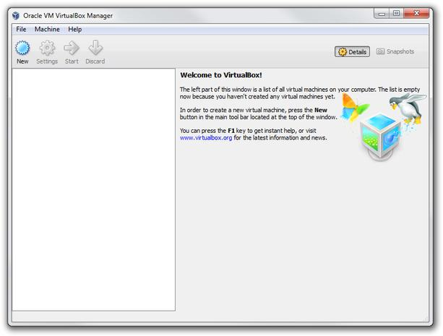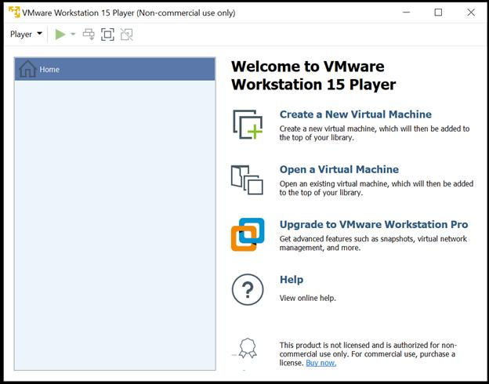

Caption:
Step 1: Install Oracle VM VirtualBox or VMware Workstation Player.

2. Create a New Virtual Machine
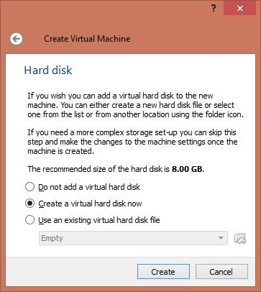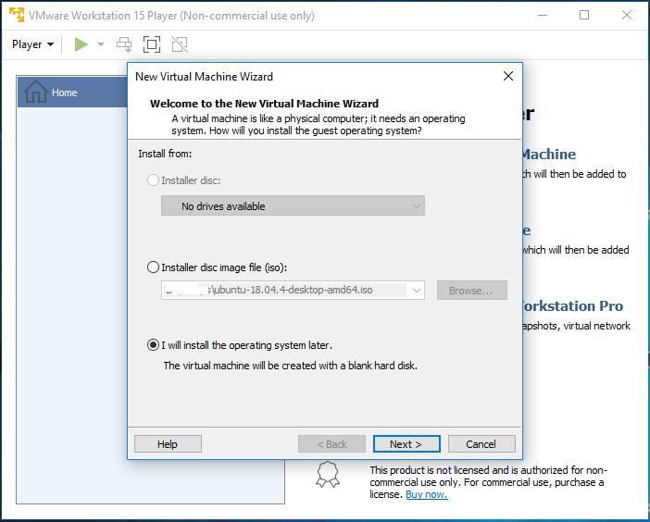

Caption:
Step 2: Create a new virtual machine.

3. Configure the Virtual Machine
Configure:
- Name: Ubuntu Desktop
- RAM: 4096 MB (4 GB)
- CPU: 2 Processors
- Disk Size: 25 GB (Dynamic Allocation)
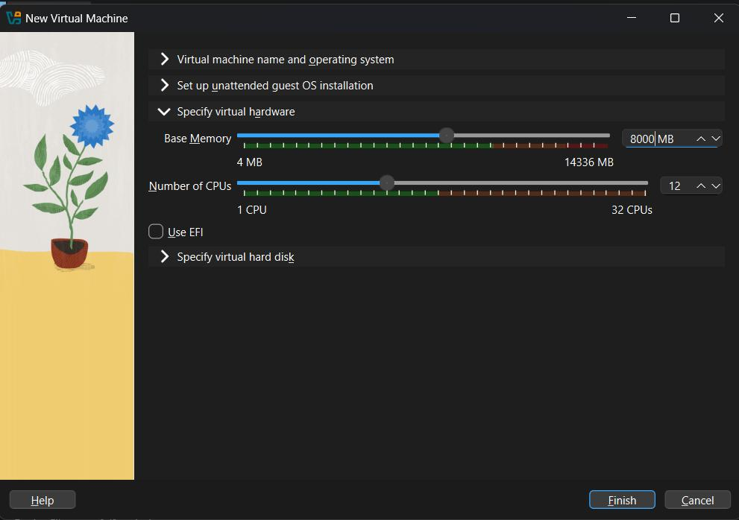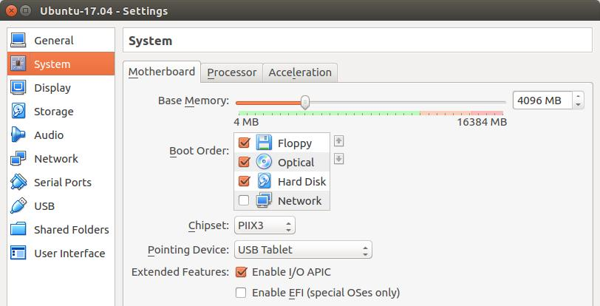

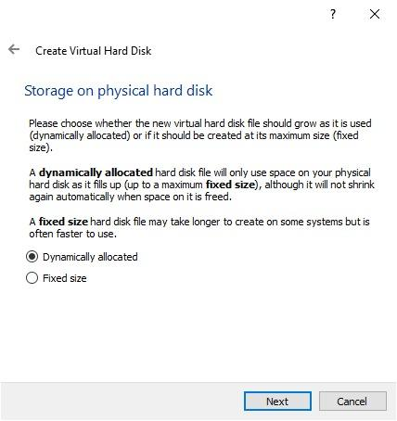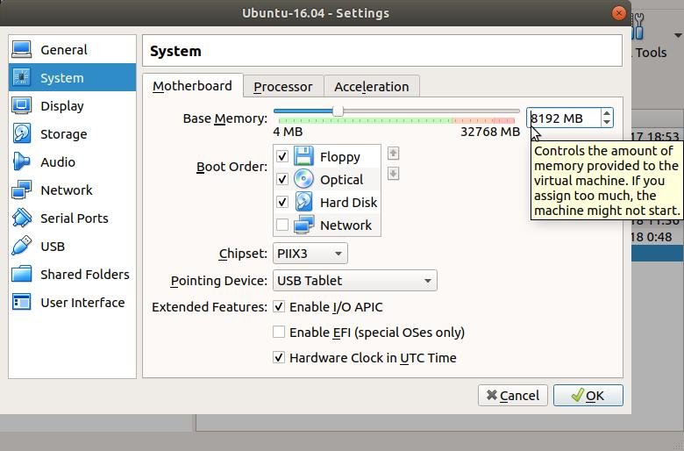
4
Caption:
Step 3: Configure the virtual machine with the required memory, processors, and dynamically allocated virtual hard disk.

4. Mount the Ubuntu ISO Image
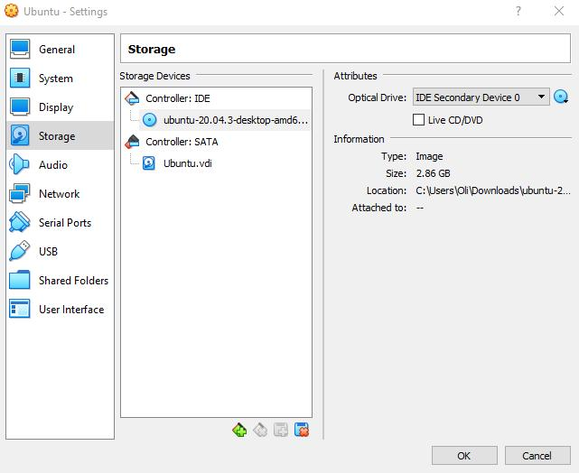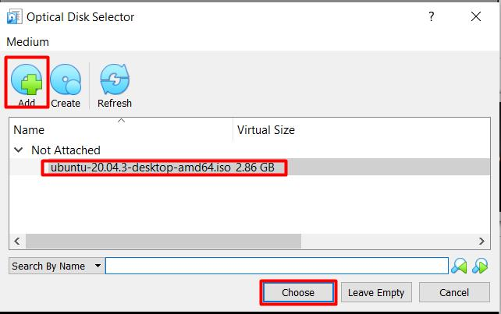

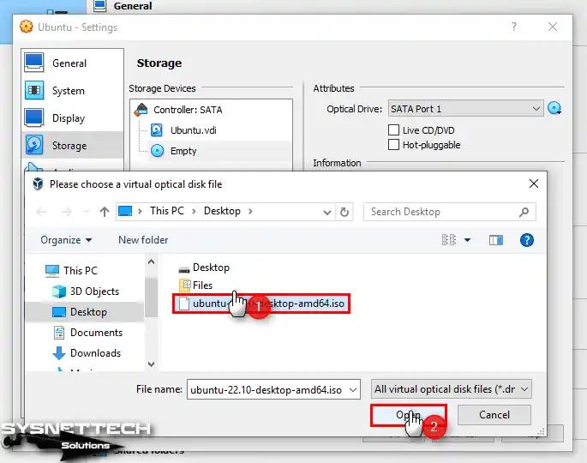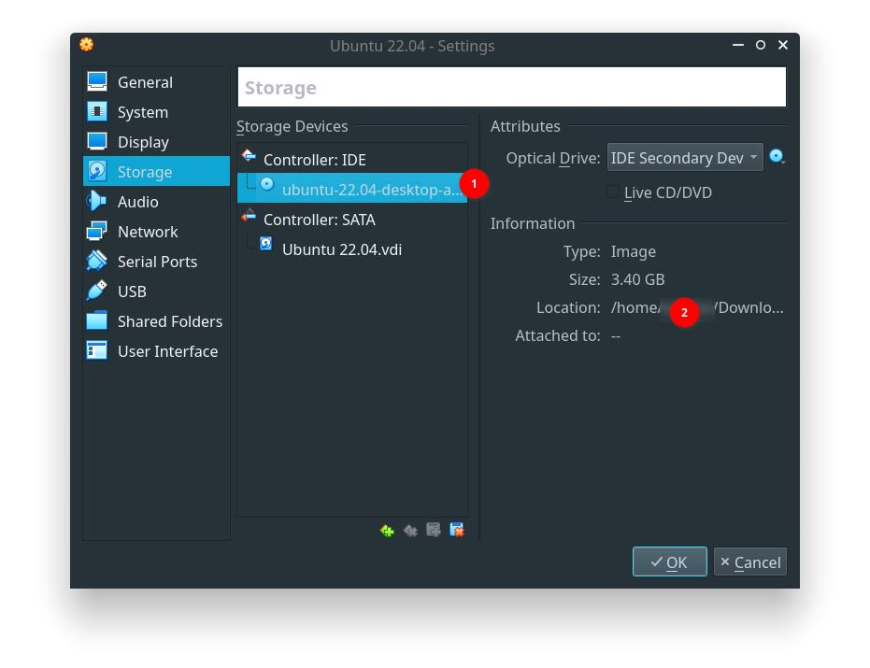
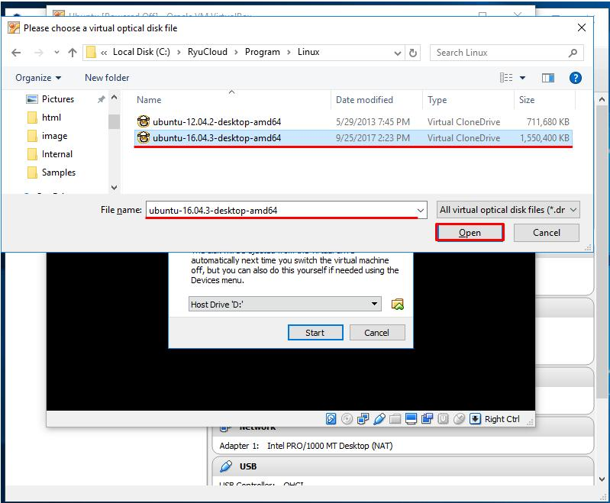
5
Caption:
Step 4: Attach the Ubuntu Desktop ISO file as the virtual optical disk.

5. Start the Virtual Machine
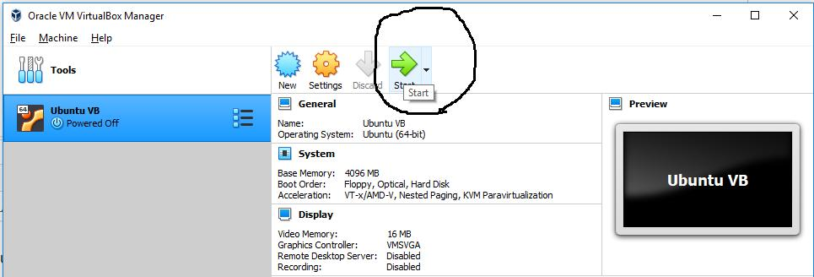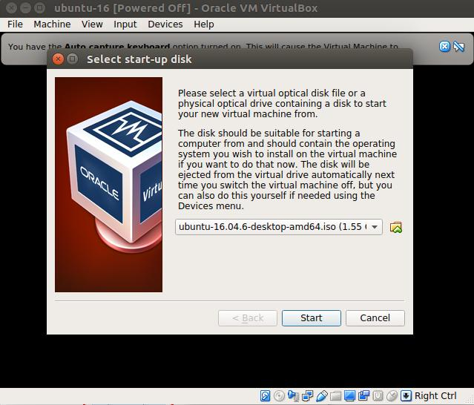

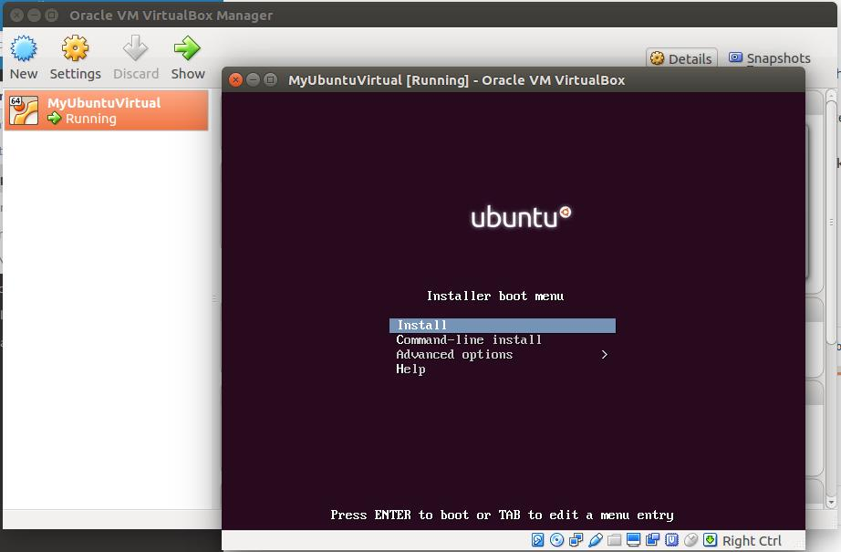
5
Caption:
Step 5: Start the virtual machine and boot from the Ubuntu ISO.

6. Click "Install Ubuntu"
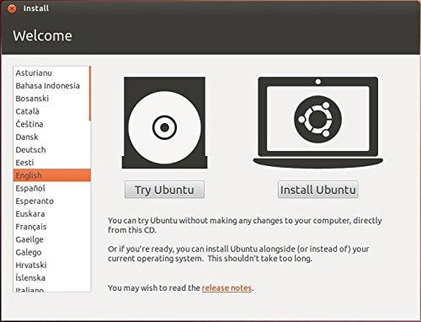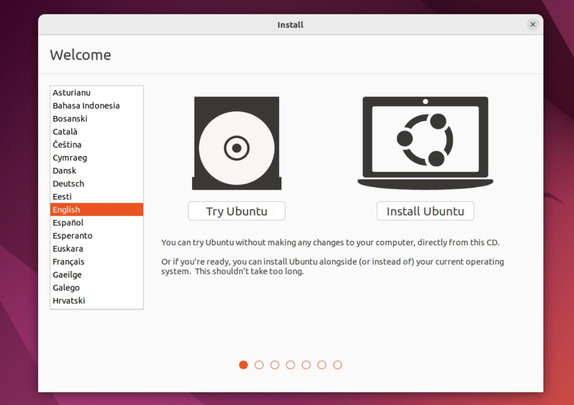

Caption:
Step 6: Click Install Ubuntu to begin the installation.

7. Select Language
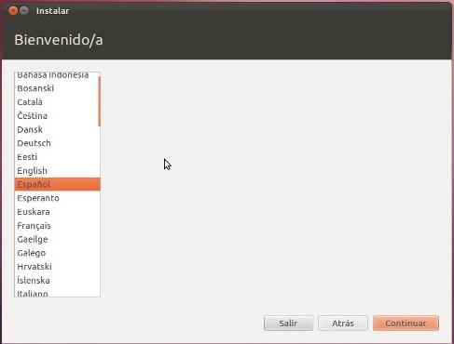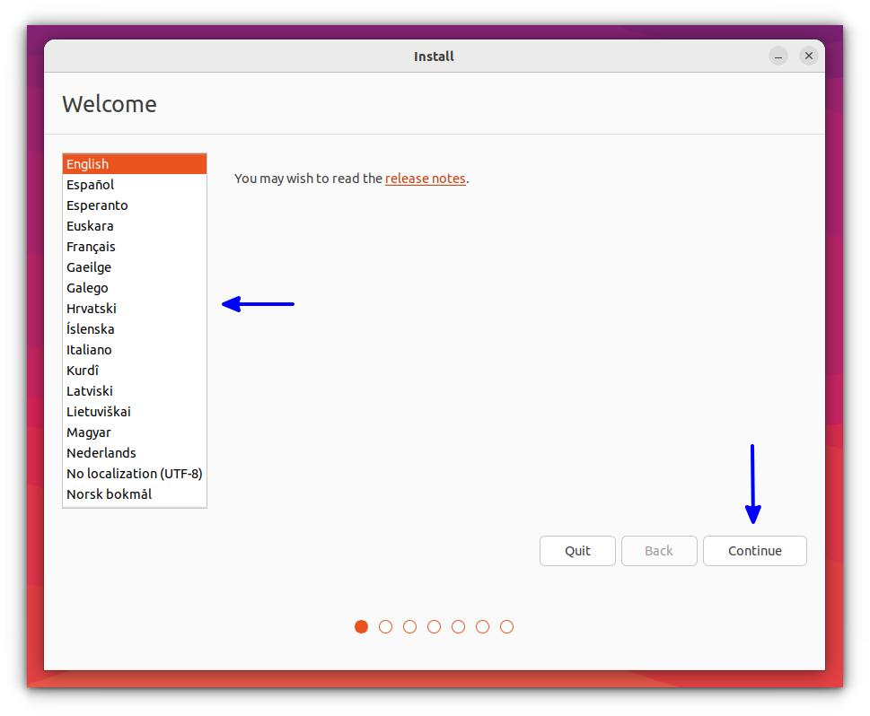

Caption:
Step 7: Select the preferred installation language.

8. Select Keyboard Layout
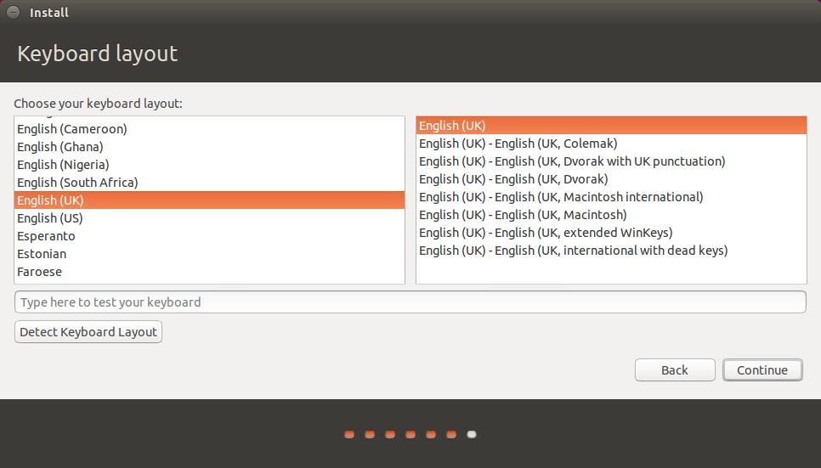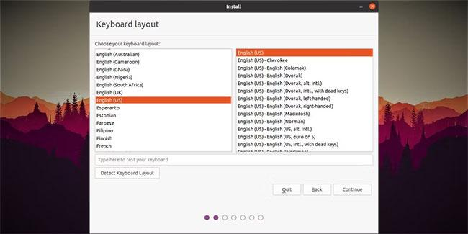

Caption:
Step 8: Choose the keyboard layout.

9. Choose Normal Installation
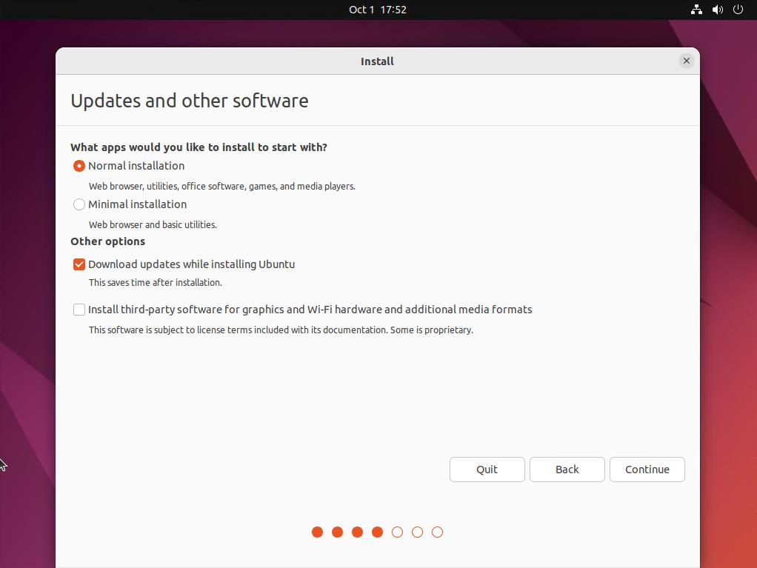
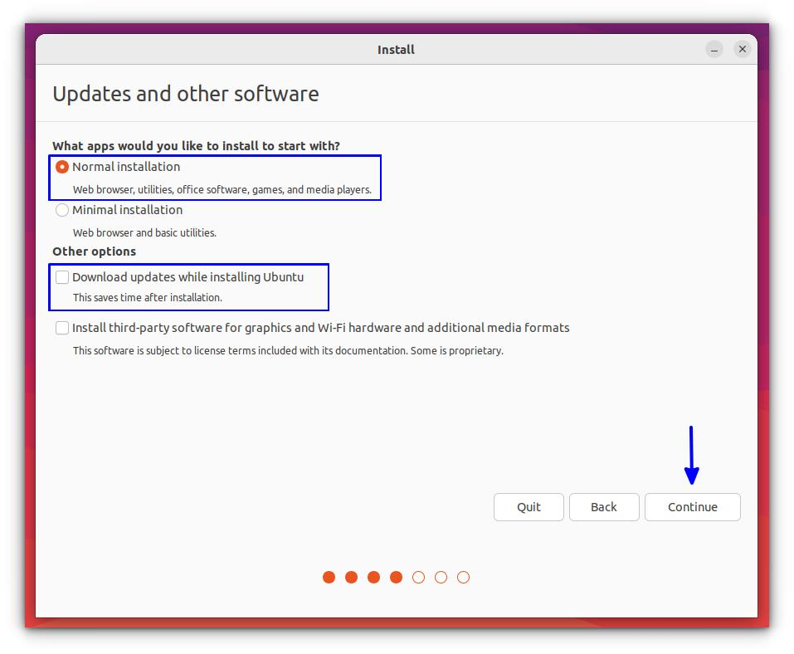

Caption:
Step 9: Select Normal Installation.

10. Select "Erase Disk and Install Ubuntu"
Note: This only erases the virtual hard disk inside the VM, not your real computer.
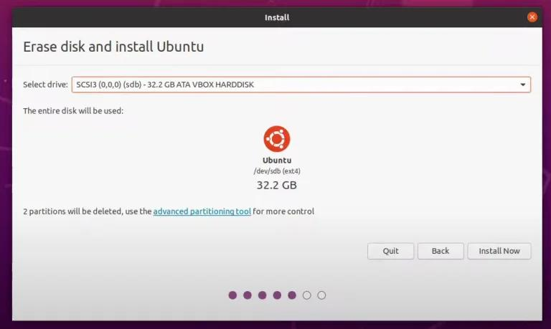
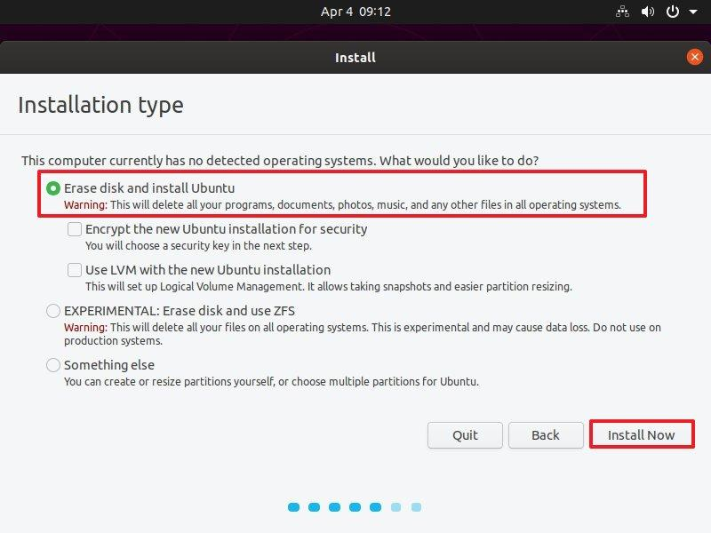
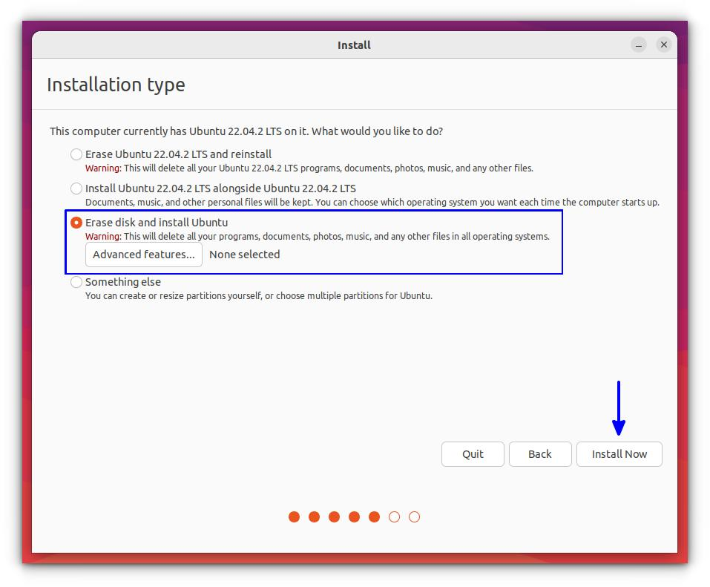
4
Caption:
Step 10: Select Erase Disk and Install Ubuntu for the virtual machine.

11. Continue Installation
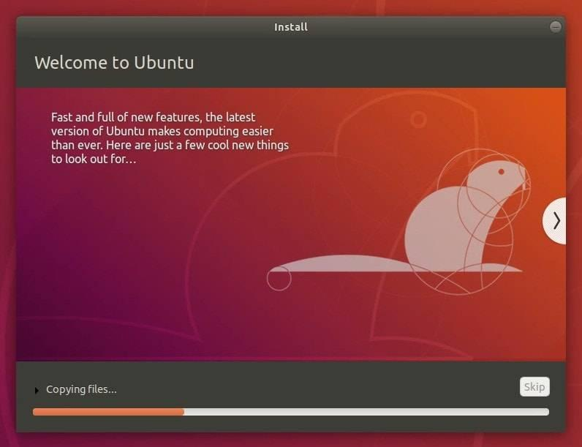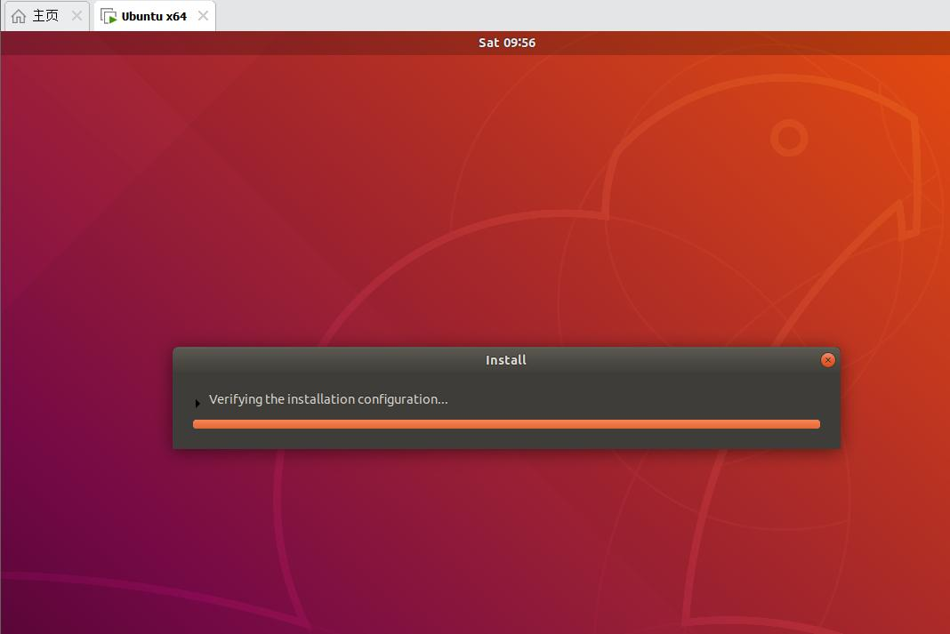
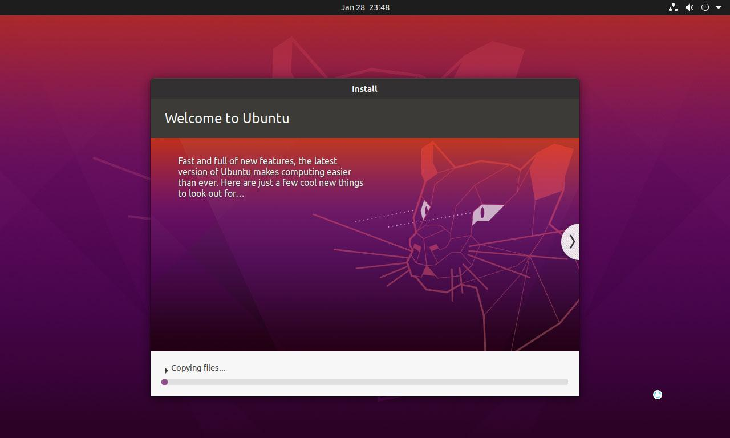

5
Caption:
Step 11: Wait while Ubuntu copies files and completes the installation.

12. Installation Complete
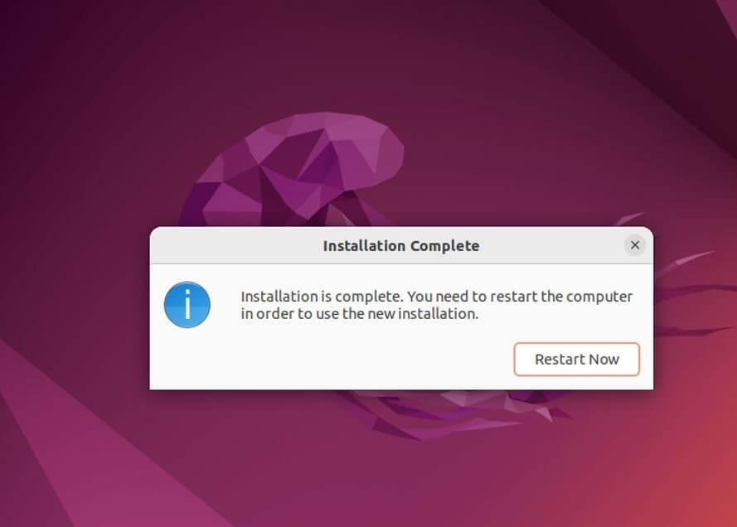
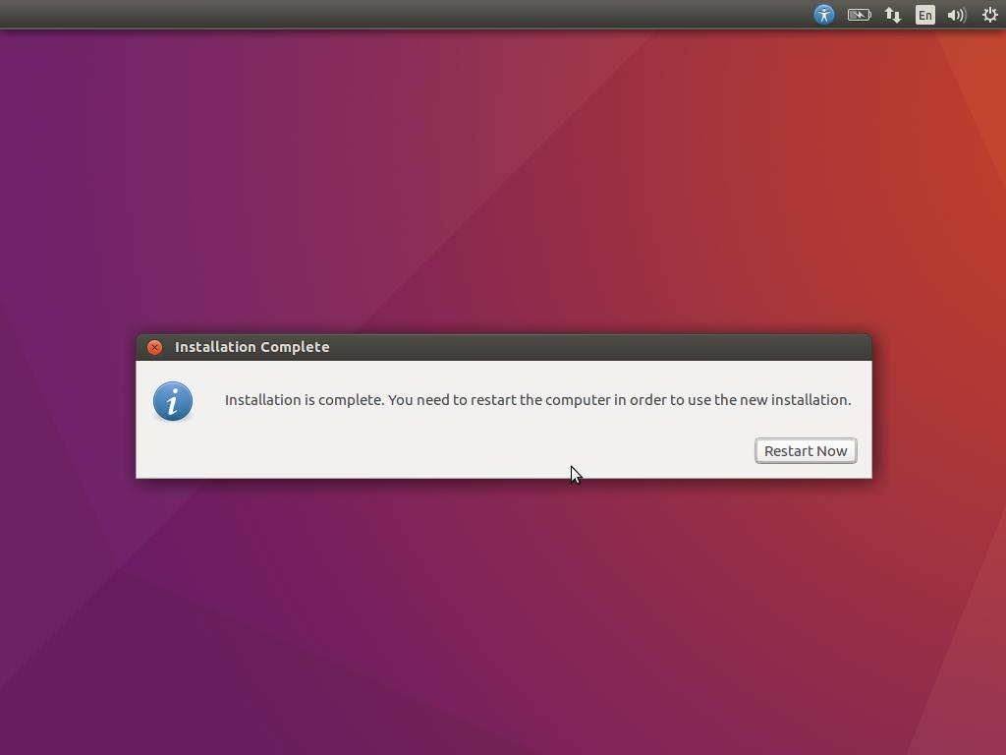
Caption:
Step 12: Installation completed successfully. Click Restart Now.

13. Restart the Virtual Machine
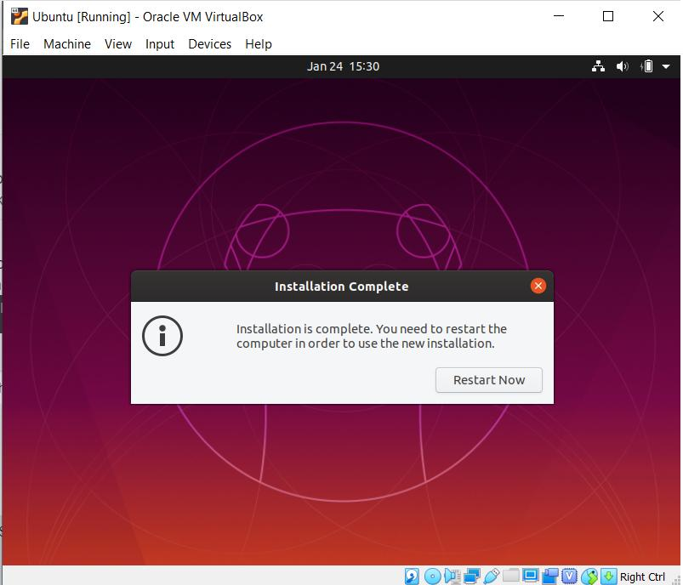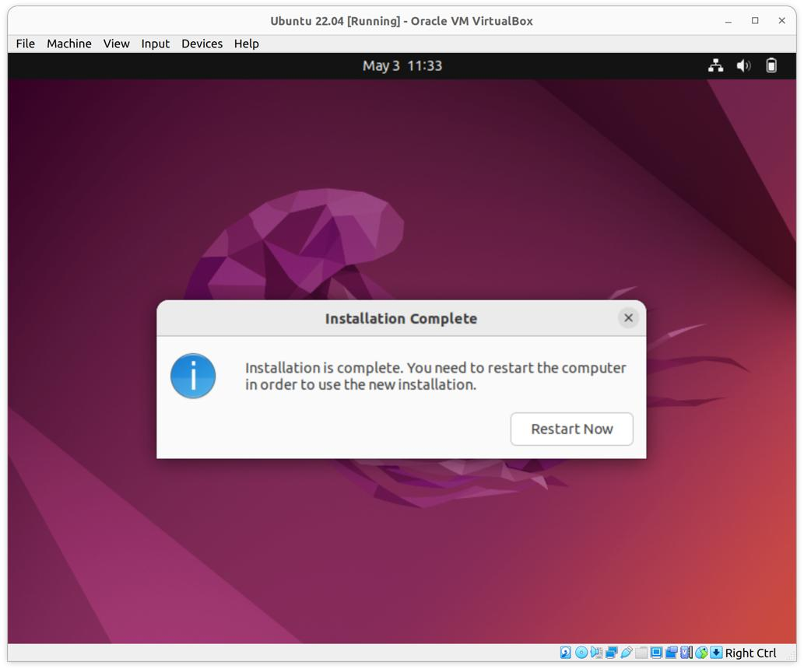

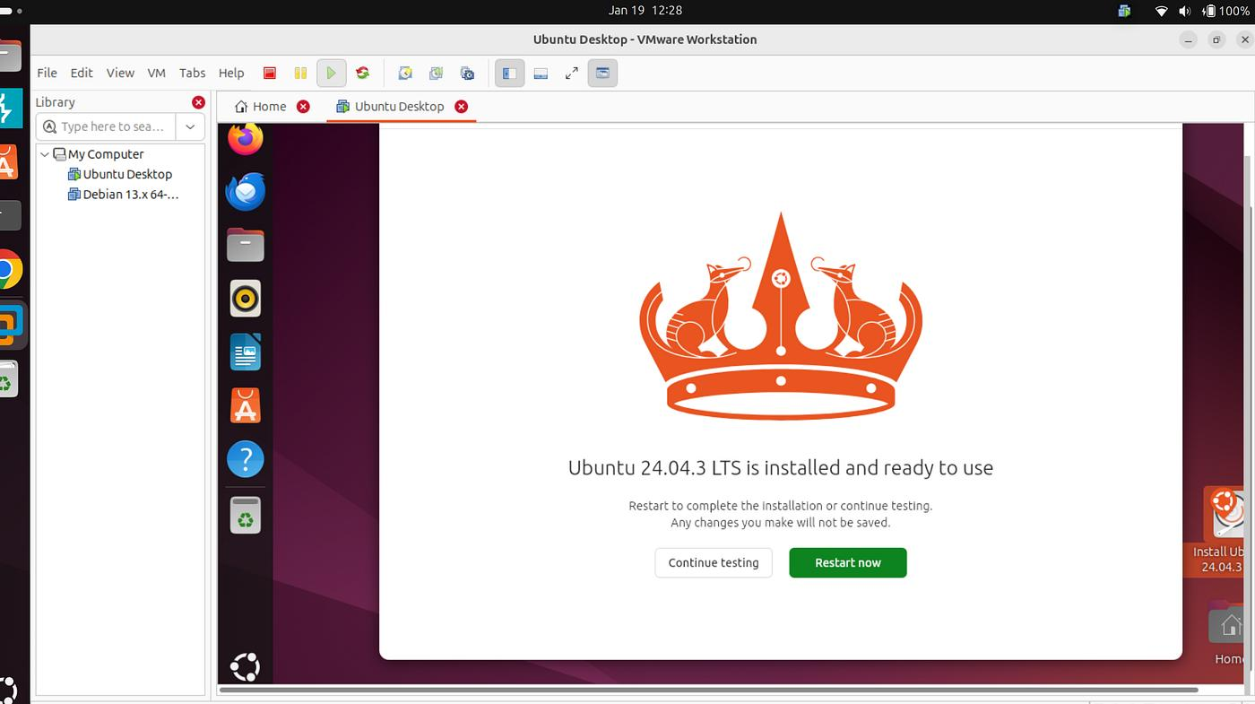
5
Caption:
Step 13: Restart the virtual machine.

14. Remove the ISO When Prompted
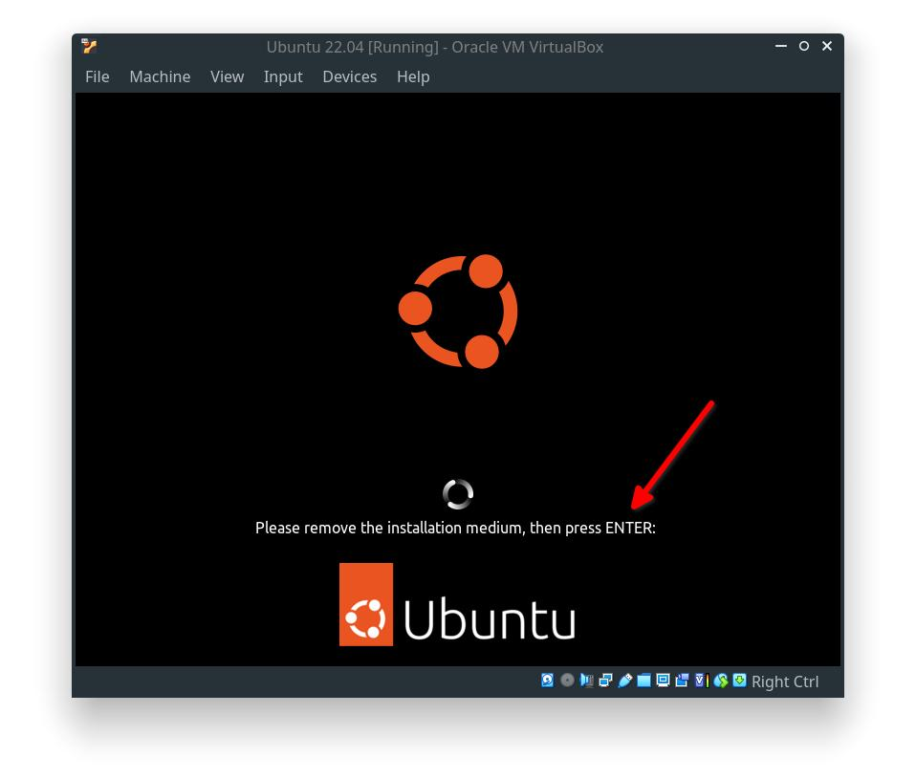
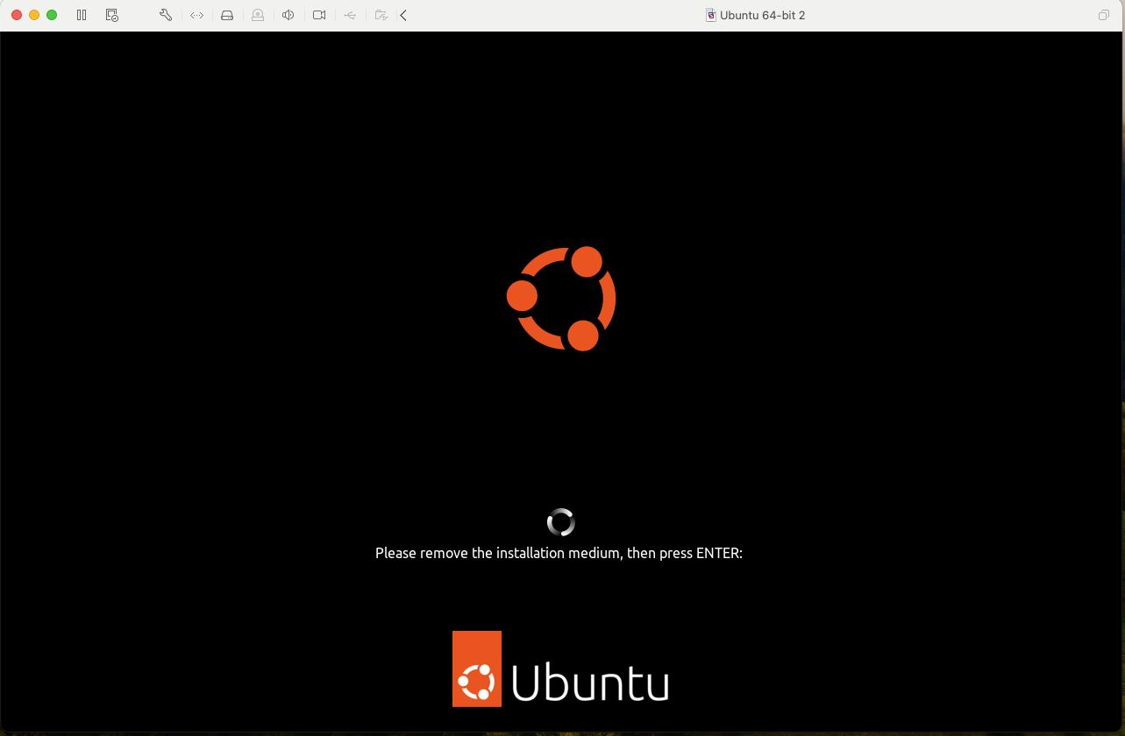

4
Caption:
Step 14: Remove the Ubuntu ISO from the virtual optical drive and press Enter to continue.

🔹 Task 3: Create User Account
During installation, create the following account:
Setting | Value
Username | cyberstudent
Computer Name | Ubuntu-PC (or any name)
Password | Cyber@123
Note: The password must contain at least 8 characters with uppercase letters, lowercase letters, numbers, and special characters.
Result:
A secure user account named cyberstudent is successfully created.

🔹 Task 4: Display Operating System Information
Steps:
open the terminal and run the command 'uname -a' to display OS details. Save the output to a text file named os-info.txt.
